.

3rd Year Project

2nd Iteration

Due 04/03/2016

## 2D Side-Scrolling Unity Game

X00109563 Gavin Hickey

X00084044 Alvis Togatovs

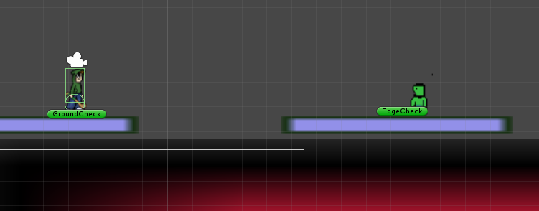

# What Have We Developed?

In this iteration we have gone over more of the core gameplay aspects and scripts that will be used and developed in order to have more function working within the game.

These scripts will be programmed to create the different functionalities within the game. Each script serves a different purpose and some work together in order to perform a certain function.

Some of the aspects we have researched and developed are:

* Respawns and Checkpoints
* Moving Platforms
* Enemy Interaction
* Following Camera

With more of these types of aspects being developed we aim to have more and more functions in our game that will create a fun and enjoyable experience for the player.

**Respawn And Checkpoints**



*Above is the character into a red respawn zone*

1. **Success** – User respawns at a checkpoint
   1. User dies, whether this be from falling off the map, to an enemy or environmental dangers
   2. The User respawns a a predetermined location on the level that they had past previously
2. **Failure** – Character does not respawn
   1. User falls through the respawn zone but does not activate the respawn script.
   2. The user will continually fall infinitely due to there being no script to cause the play to respawn in the checkpoint location

**Fix:** This error was fixed by checking the “isTriggered” box within the fall zone object. Without this being ticked the script would not be activated when the player comes into contact with the zone.

**Moving Platforms**

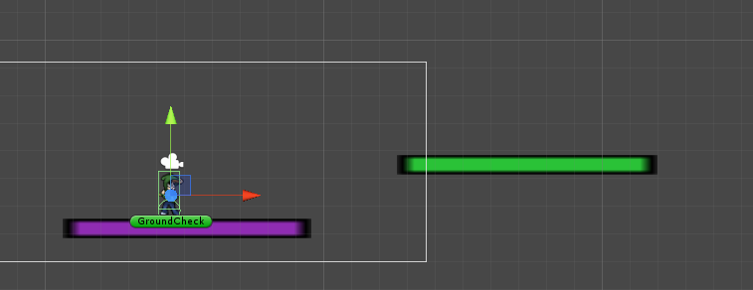

*Above is the scene view in Unity of the character using a vertical moving platform (purple) to reach a horizontal moving platform (green)*

1. **Success** – User lands on Platform and moves with the Platform
   1. The User lands on the moving platform as it moves.
   2. The User stays on said platform and move with it.
2. **Failure** – Character slides off the platform
   1. User lands on the moving platform as it moves.
   2. The User the begins to slide off the platform as it moves away.
   3. The player slides off and falls off the platform

**Fix:** To fix this issue we made the platform be tagged the same as the other platforms so it was recognised as a ground object by the character and therefore the character would connect to it properly and not slide off.

**Enemy’s interaction with player.**



Enemy character where created on the “Piskel” online tool, that has two snapshots for movement behaviour.

Where designed movement on the platform with the C# scripting , the enemy’s main task is to walk on the platform for certain area , when the enemy reaches platform edge its task is to turn around on 180 degrees and walk up to the other side of the edge of the same platform.

Whenever enemy touches the players character it will kill him, the player automatically will re-spawn at the nearest reached checkpoint, however the players lives will decrease every time when player re-spawn by 1 point.

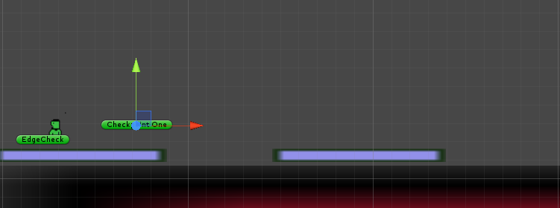

**Player’s interaction with enemy.**

To avoid player being killed, the player needs to avoid any contact with enemy or he may use he’s weapon which is hurling stick, by hitting enemy with stick the enemy will killed and will disappear from the platform it was standing on.

**The main problems occurred by designing enemy character.**

1. Creating animation and implementing in the Unity engine
2. While researching scripting techniques we found a lot incompatibilities with coding with C#, mostly tutorials that are available online are made on the older version “Unity 4.3”, this is the most common version for online tutorials. At the moment we are using “Unity 5.3”. This was the main error causing problems.
3. To fix the problem we searched online , on game developer forums, by finding the typical problems with the coding behaviour and using the solutions suggested to fix the problems.

**Following Camera**

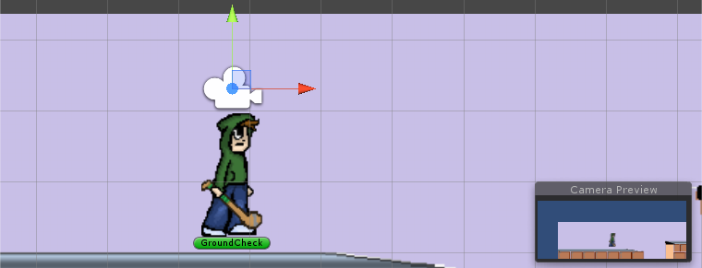

Main camera

**The problems occurred with main camera.**

The game was created with a main camera that follows the main character for displaying our game to the player. The camera can be set to render in any order, at any place on the screen, or only certain parts of the screen.

1. At the very beginning of the game that the camera stud at the place and was only showing starting point and it never followed the character.
2. To fix the camera problem, the main camera was implemented as a child object of the main character.

# Changes to Overall Project

At this current point in time it is unknown whether or not any drastic change to the game will be made, we are covering our bases and showing that the core elements are being developed so that we can later focus on some of the less necessary game play functions.

It is still known that some of the earlier goals might not be reached such as having so many level and possibly the multiplayer functionality. The projects scale in terms of how many levels will there be may be reduced as the development of even one level is a very time consuming process, such time we can better allocated to different functions that might need to be worked on in the game.

Therefore we will not be creating as many level but instead creating more objects to be included within each level for the player to use and interact with.

We will not be able to determine whether or not we will have to abandon some of the projects goals at this point as we are making good progress in developing the game and depending on how this progression continues we will be unable to make a definite decision on what should or should not be dropped for the sake of the project.